Mobile_Lesson5: Working with SQLite and Firebase

ICP GROUP: 38

ICP 12

Name: Anil Kumar Reddy

Email: [anggp@umsystem.edu](mailto:anggp@umsystem.edu)

ICP12 Repository: <https://github.com/UMKC-APL-WebMobileProgramming/ICP12-AnilkumarreddyNandikonda>

ICP12 source code link:

Firebase: <https://github.com/UMKC-APL-WebMobileProgramming/ICP12-AnilkumarreddyNandikonda/tree/main/Source/Firebase>

SQLite: <https://github.com/UMKC-APL-WebMobileProgramming/ICP12-AnilkumarreddyNandikonda/tree/main/Source/SQLite>

ICP12 Video: <https://umsystem.hosted.panopto.com/Panopto/Pages/Viewer.aspx?id=4614827d-77f0-443b-b23b-adef005c632b>

My Partner

Partner name: Abhinay Yadav

Partner Email: [ayr6y@umsystem.edu](mailto:ayr6y@umsystem.edu)

Partner Repository: <https://github.com/UMKC-APL-WebMobileProgramming/ICP12-YAbhinay>

Source Code Link

Firebase : <https://github.com/UMKC-APL-WebMobileProgramming/ICP12-YAbhinay/tree/main/Source/Firebase/app/src>

SQLite : <https://github.com/UMKC-APL-WebMobileProgramming/ICP12-YAbhinay/tree/main/Source/SQLite/app/src>

ICP12 video: <https://umsystem.hosted.panopto.com/Panopto/Pages/Viewer.aspx?id=4614827d-77f0-443b-b23b-adef005c632b>

Lesson Overview: In this lesson, we are going to discussSQLite and Firebase databases.

In Class Programming (ICP):

SQLite:

1.Open the use case SQLite provided in the source code and understand how the control flows from source code to UI

2.Add the following functionality to the

app:

•deleting employee or employer details

•Updating employee details

Firebase:

1.Open the use case 'Firebase'provided in source code and understand how the control flows from source code to UI

2.Add the following functionalities to the app:

•Log out

•Delete feature

EmployeeActivity:

* Defining the class

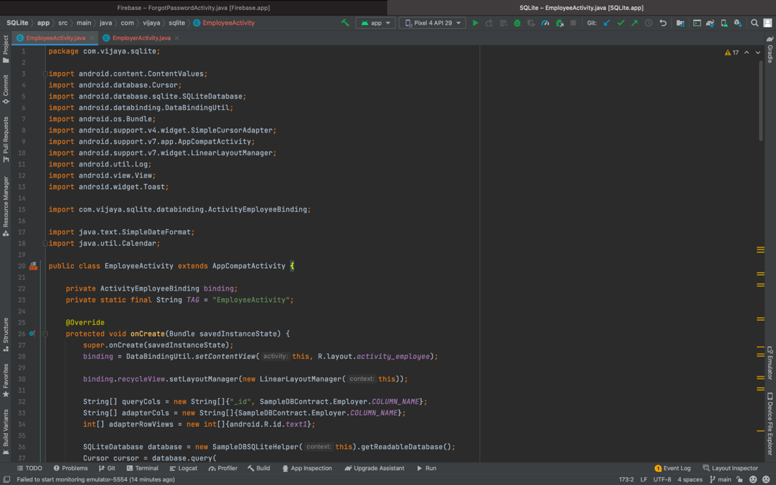

* Creating the buttons search, update, save

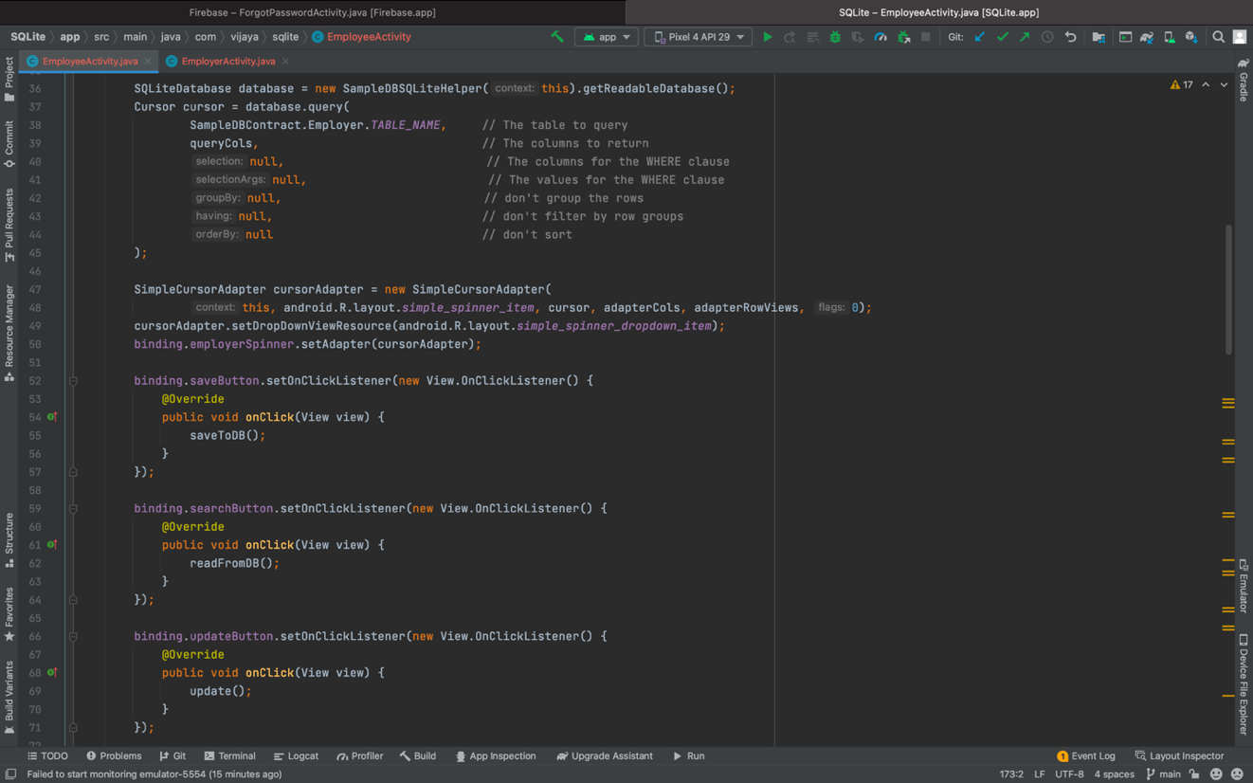

* For each TODO function method i.e save, read, update, delete. Following screenshots as the code of TODO list for Employee

1)

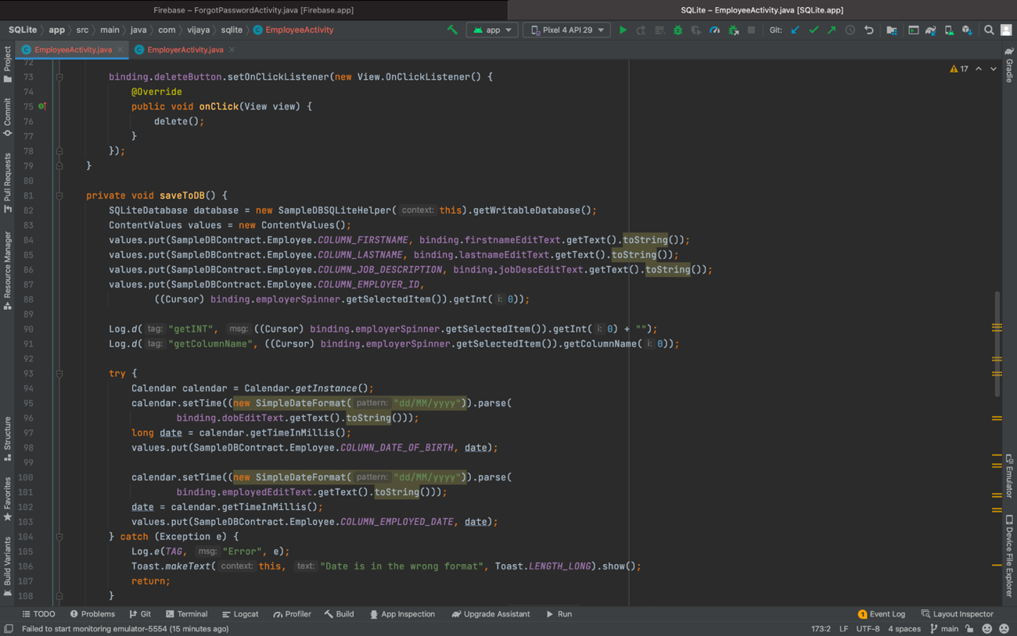

2)

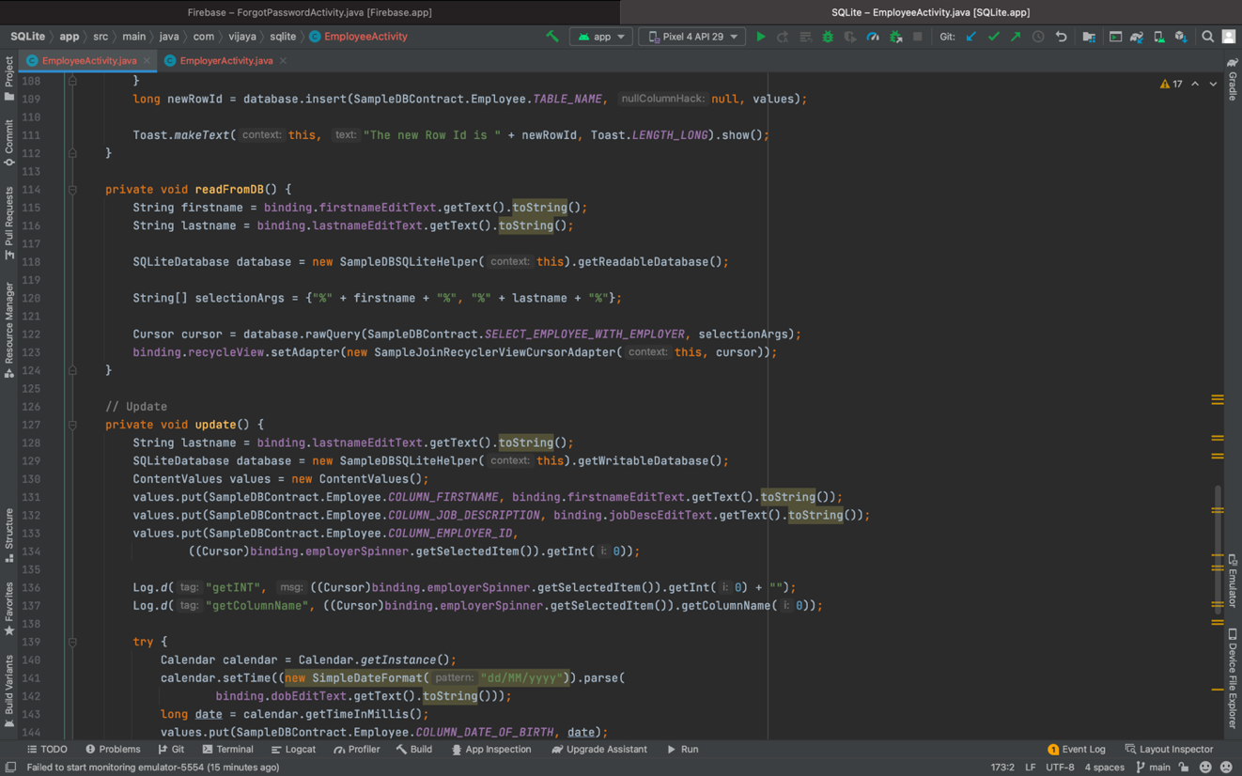

3)

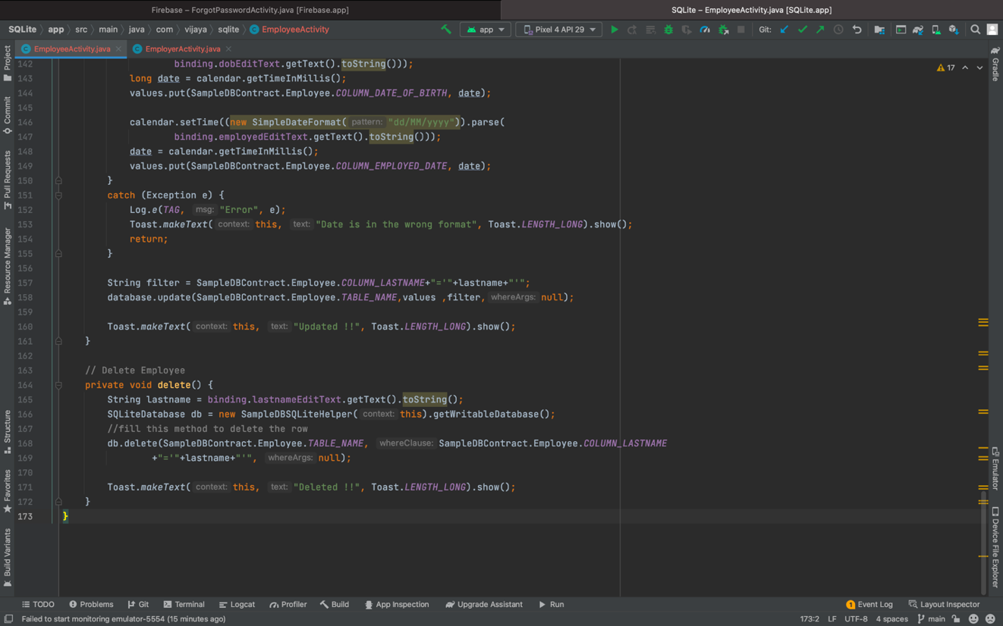

EmployerActivity:

Defining the class

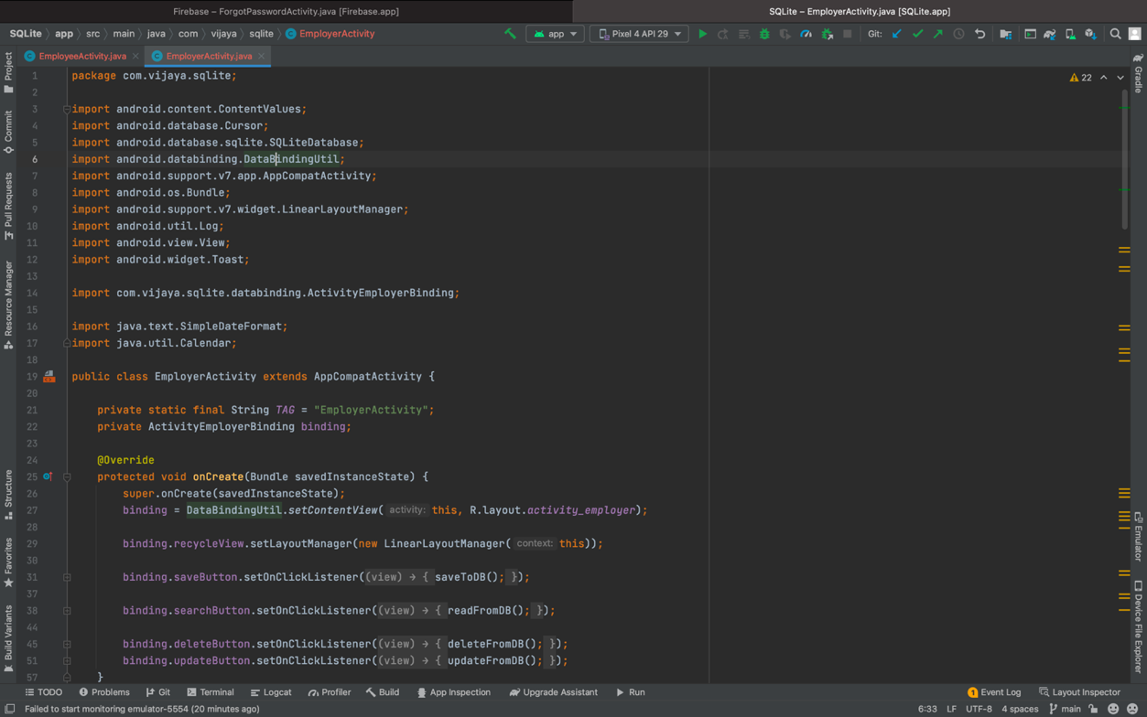

* For each TODO function method i.e save, read, update, delete. Following screenshots as the code of TODO list for EMPLOYER

1)

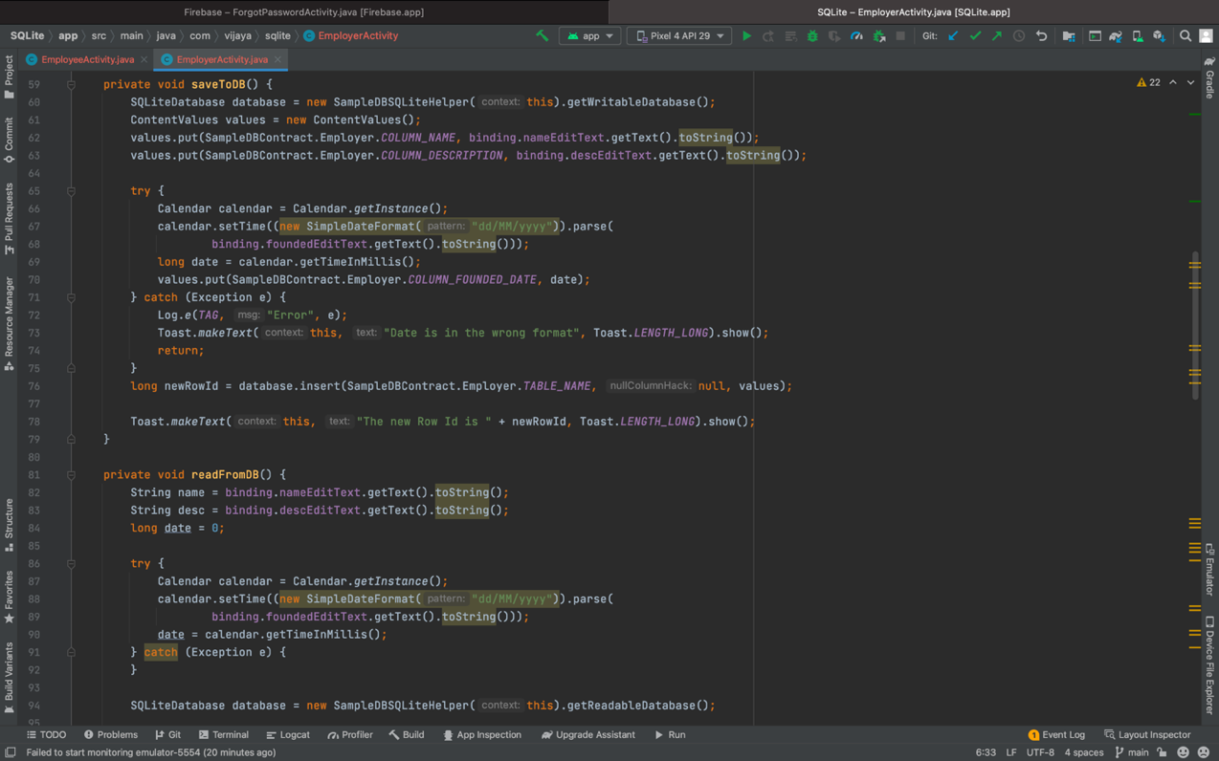

2)

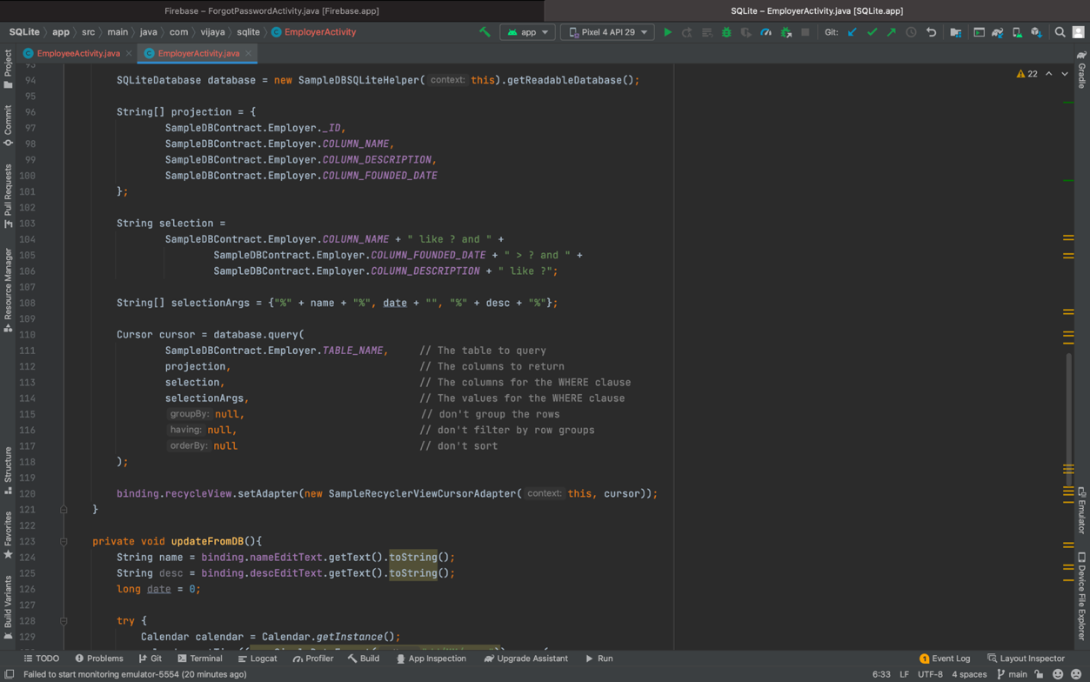

3)

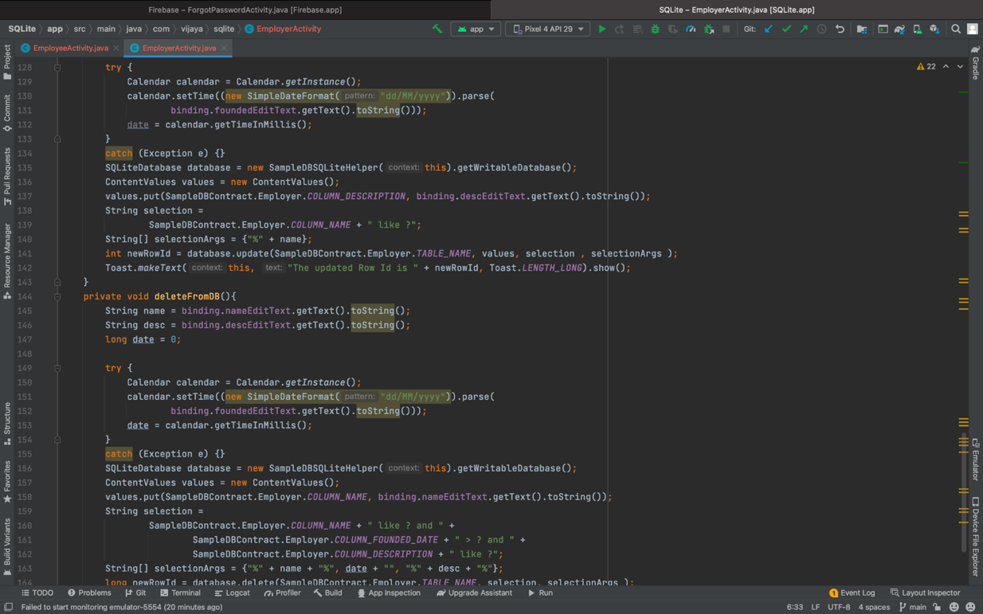

4)

4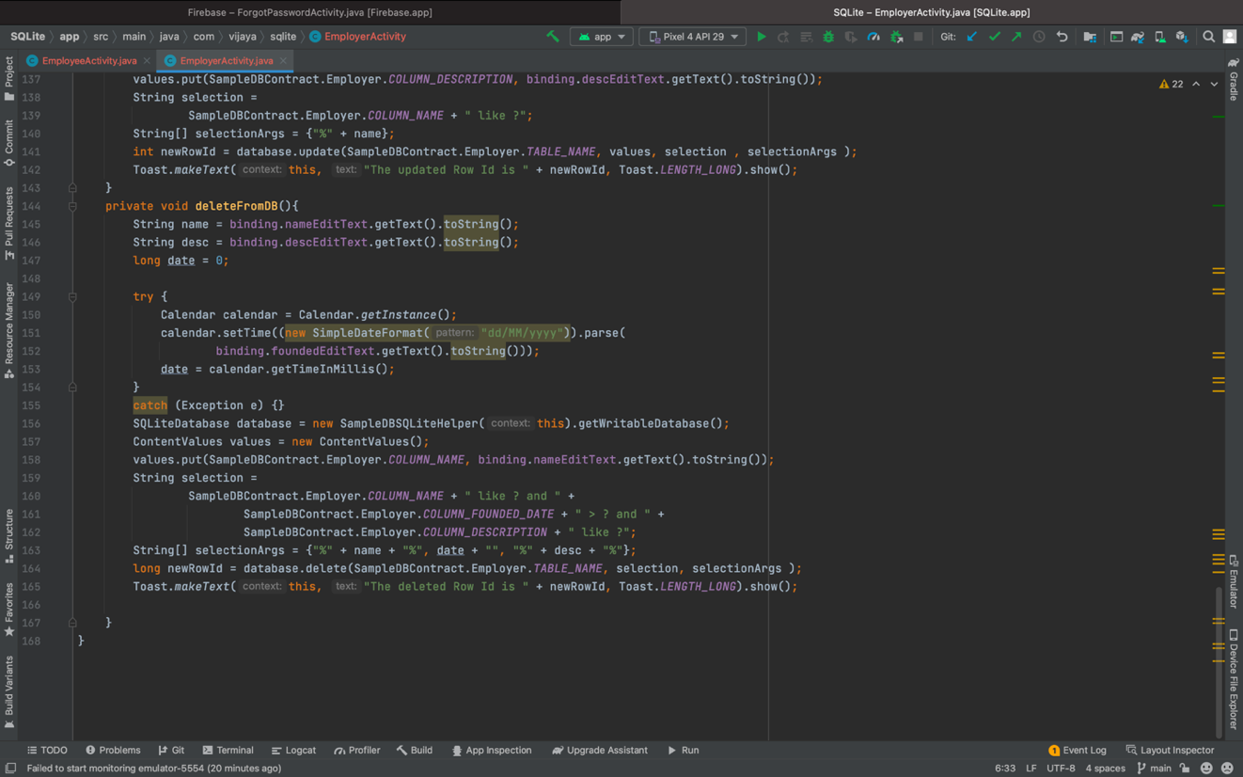

Sample Recycler View Cursor Adapter:

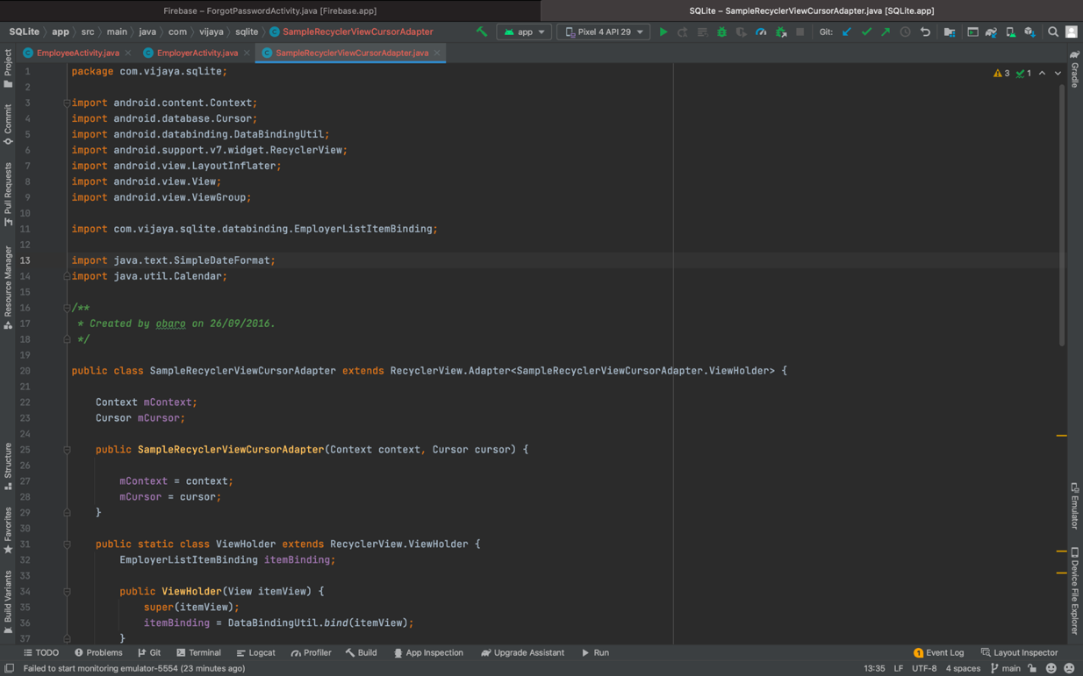

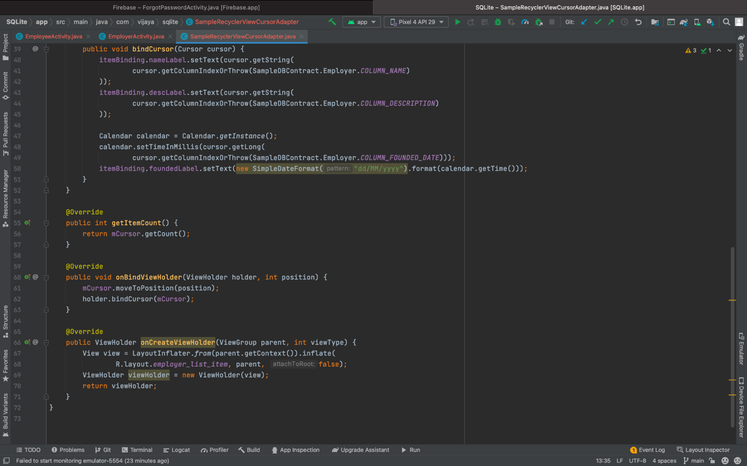

Layouts:

Activity_employee:

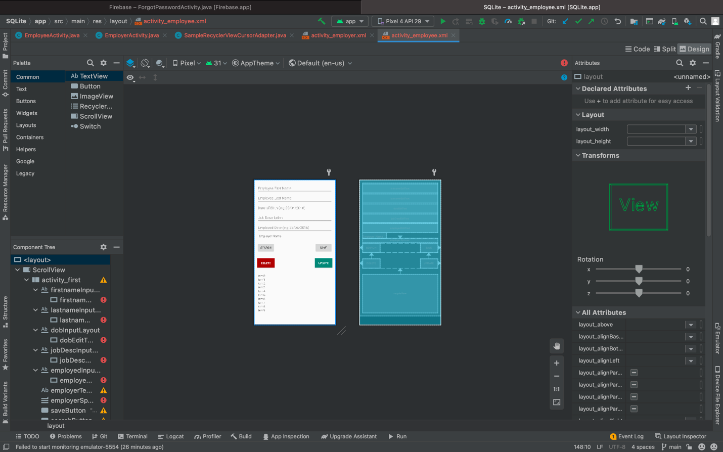

Activity_employer:

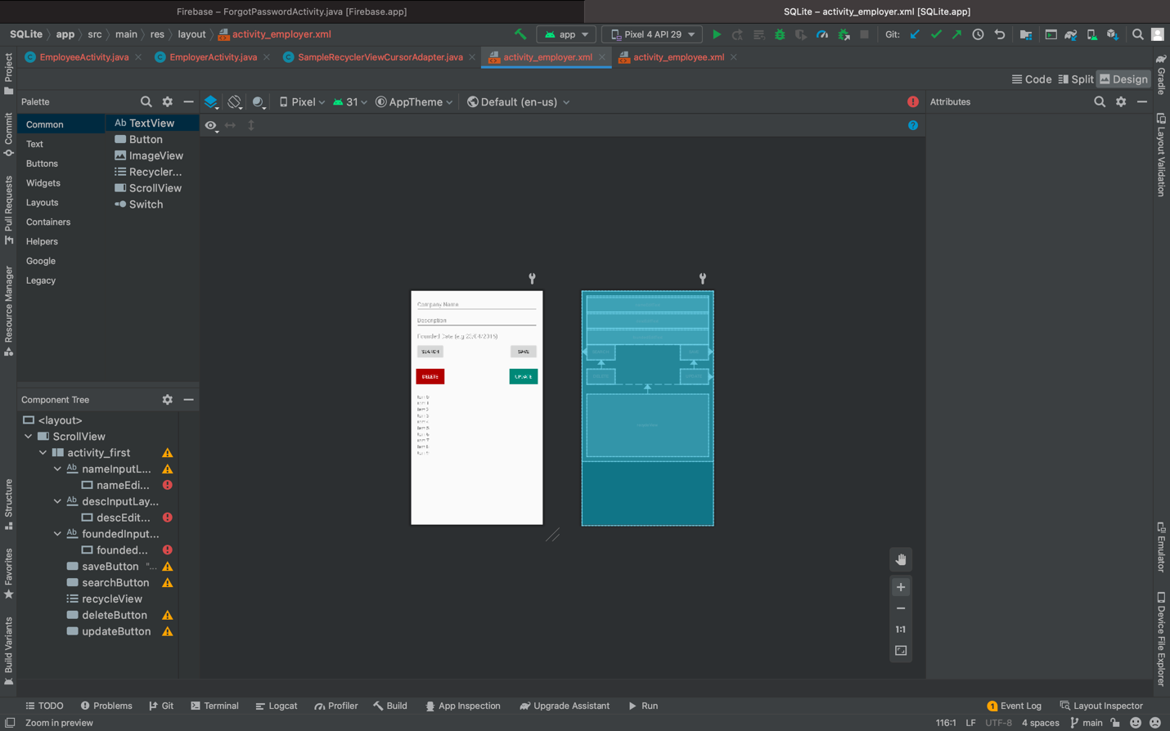

**Output:**

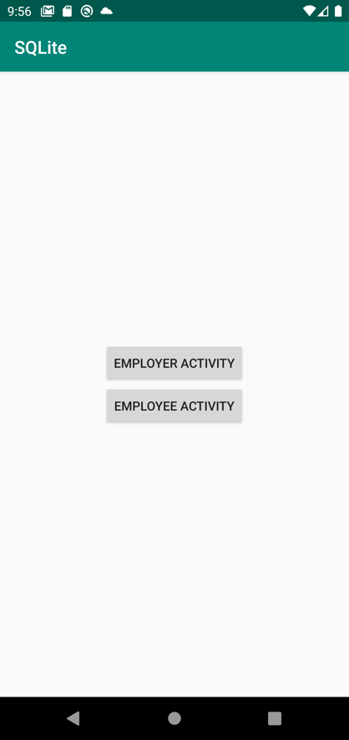

**Employer:** Here we can search, save, delete, update the employer details in the same page.

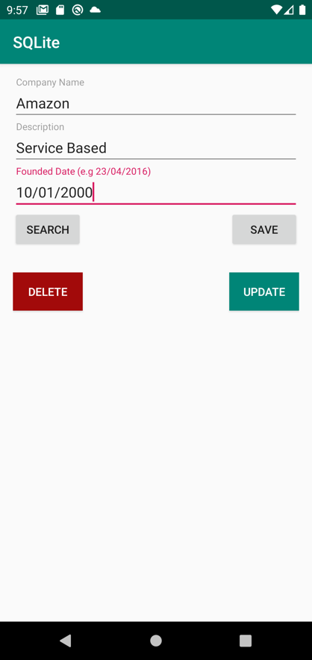

**Employee:** Here we can search, save, delete, update the employee details in the same page.

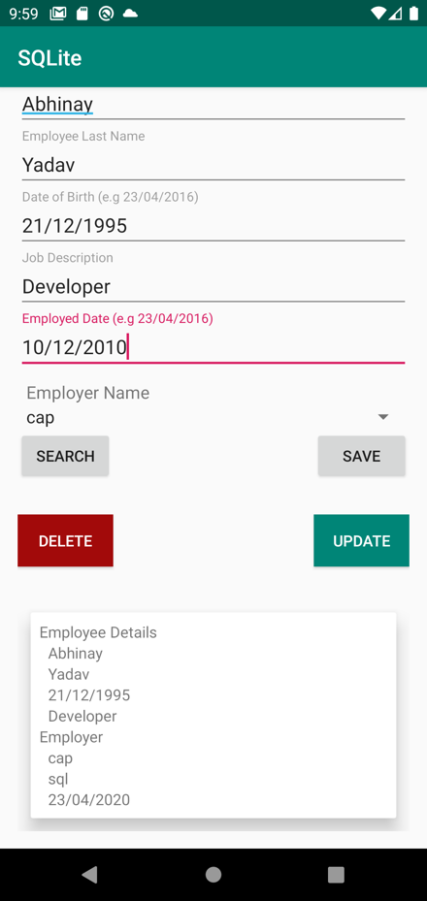

**Firebase:**

**ForgotPasswordActivity:** Defining the class ‘ ForgotPasswordActivity’

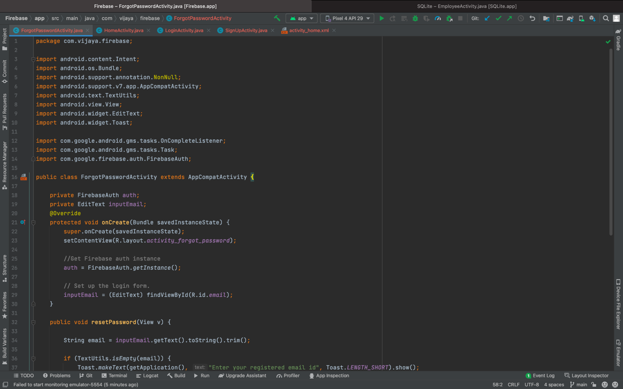

The reset password method as follows:

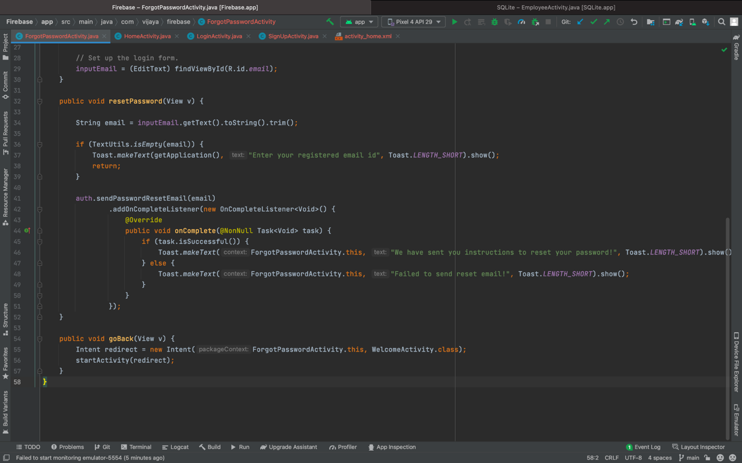

**HomeActivity:** Defining the class “HomeActivity”

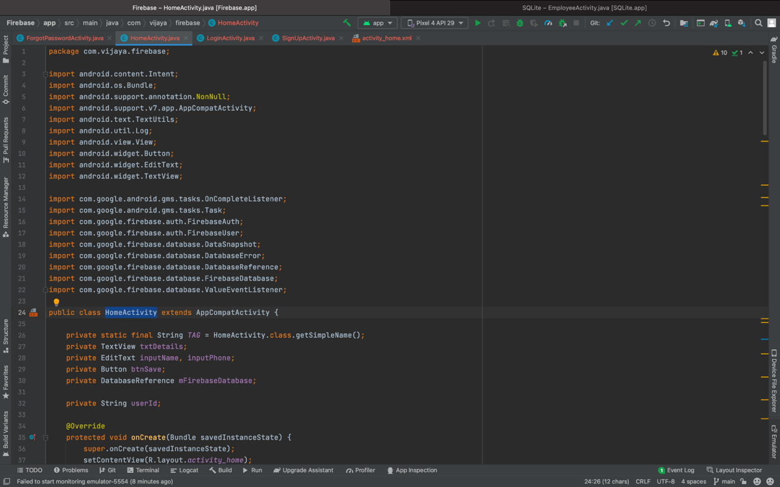

Method for create, Data change, cancelled, delete, logout

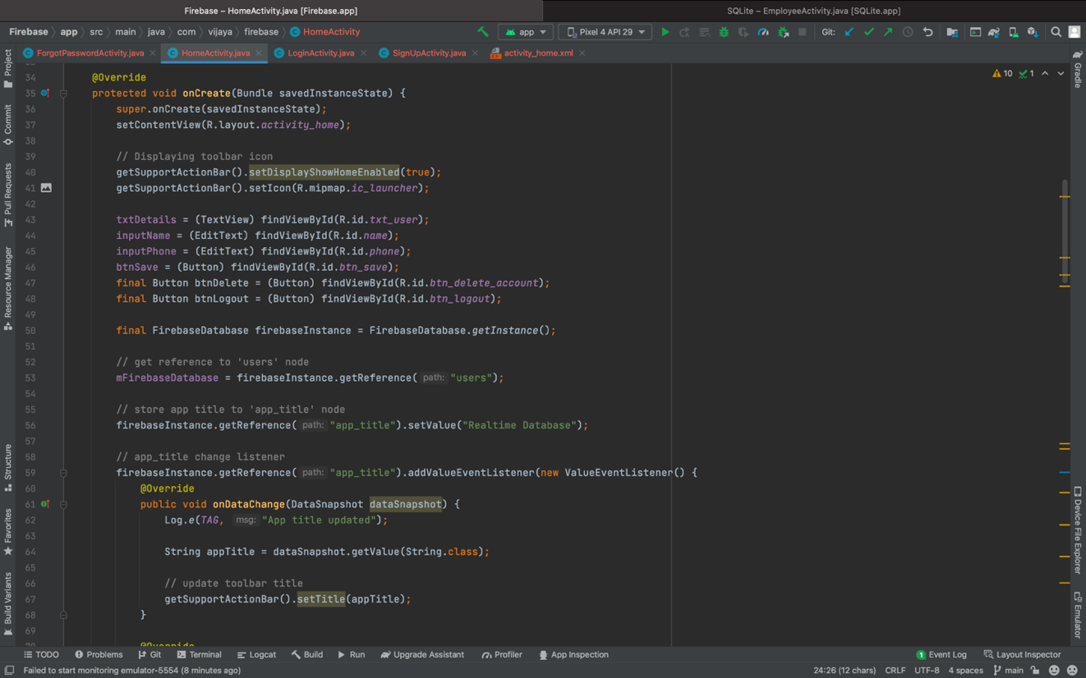

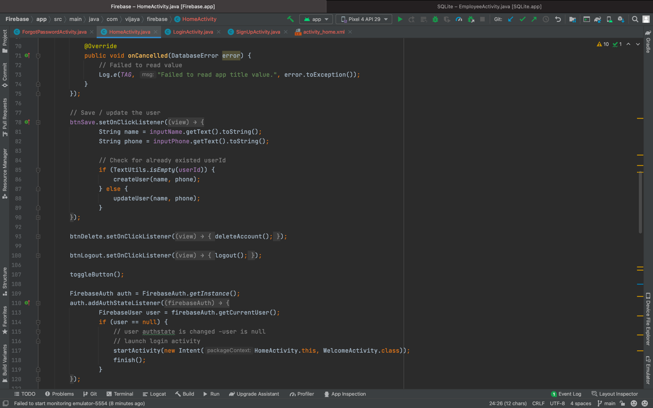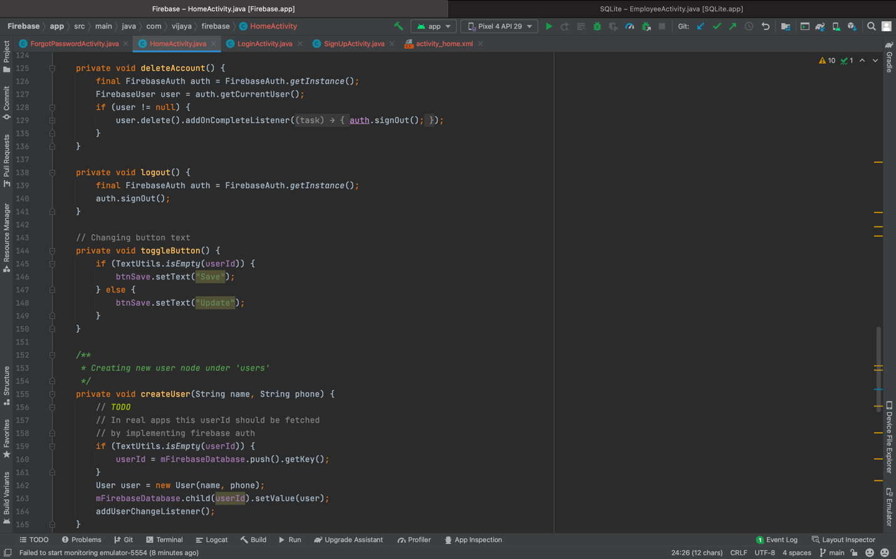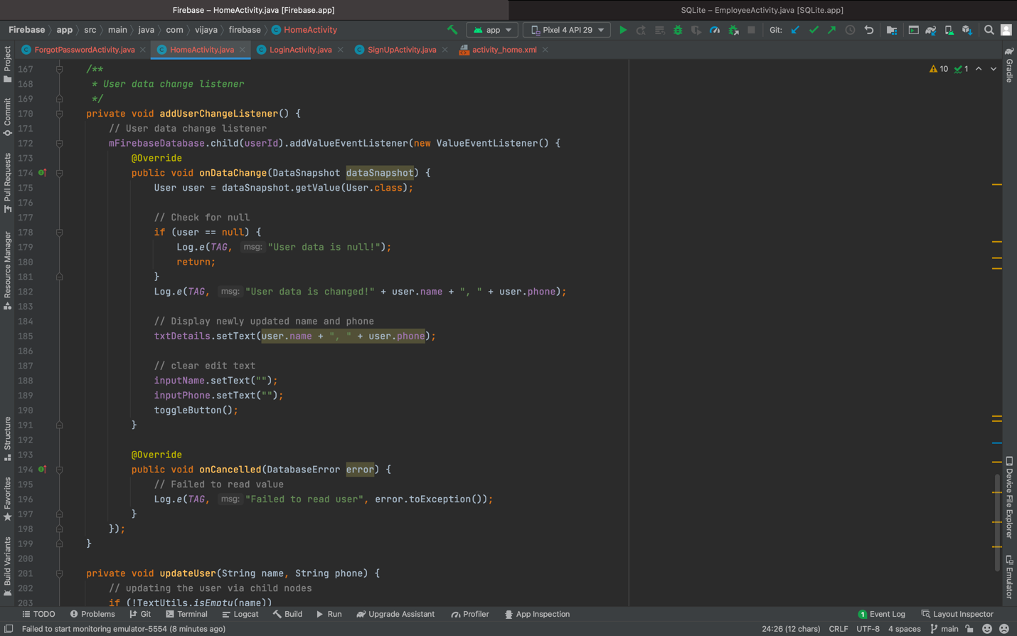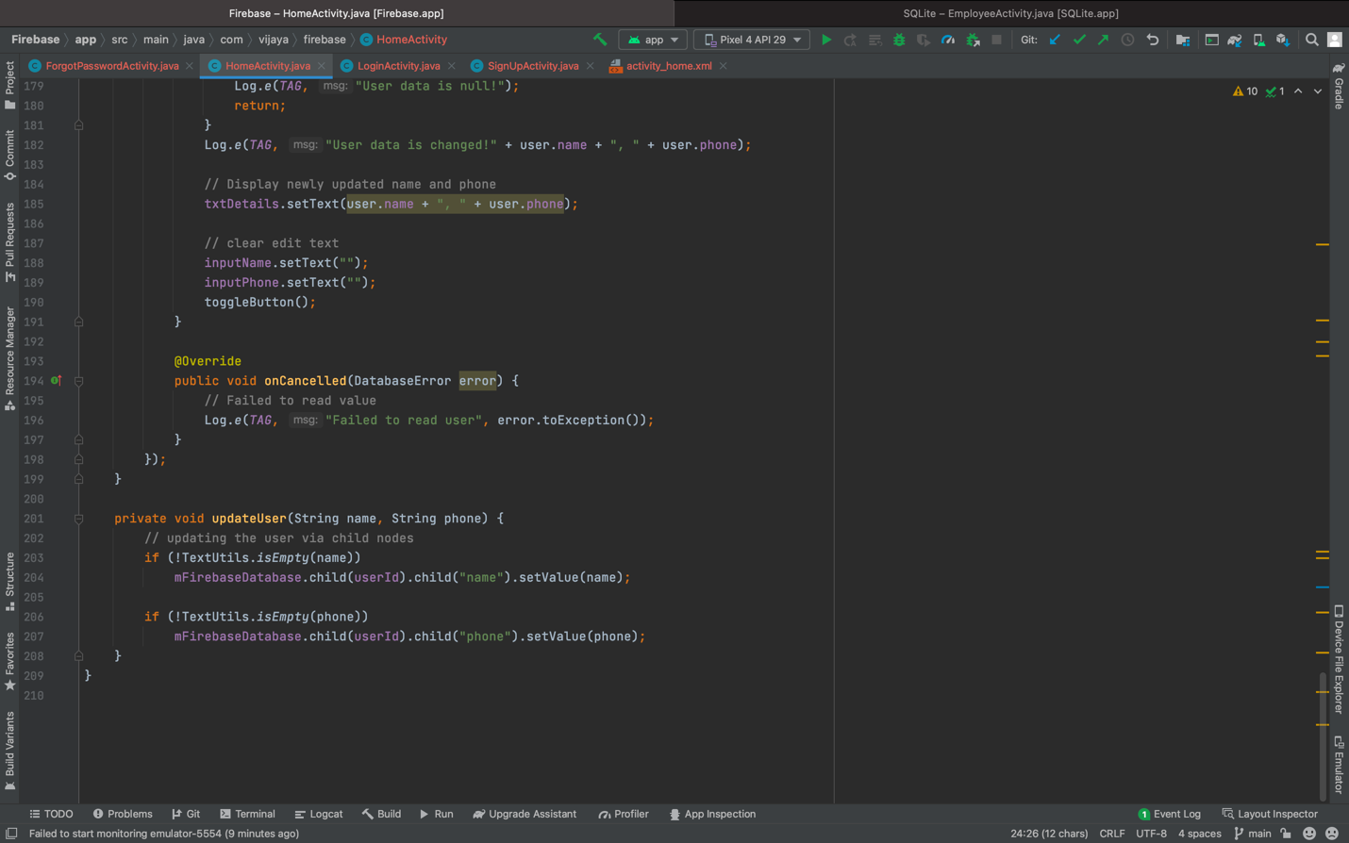

**LoginActivity:**

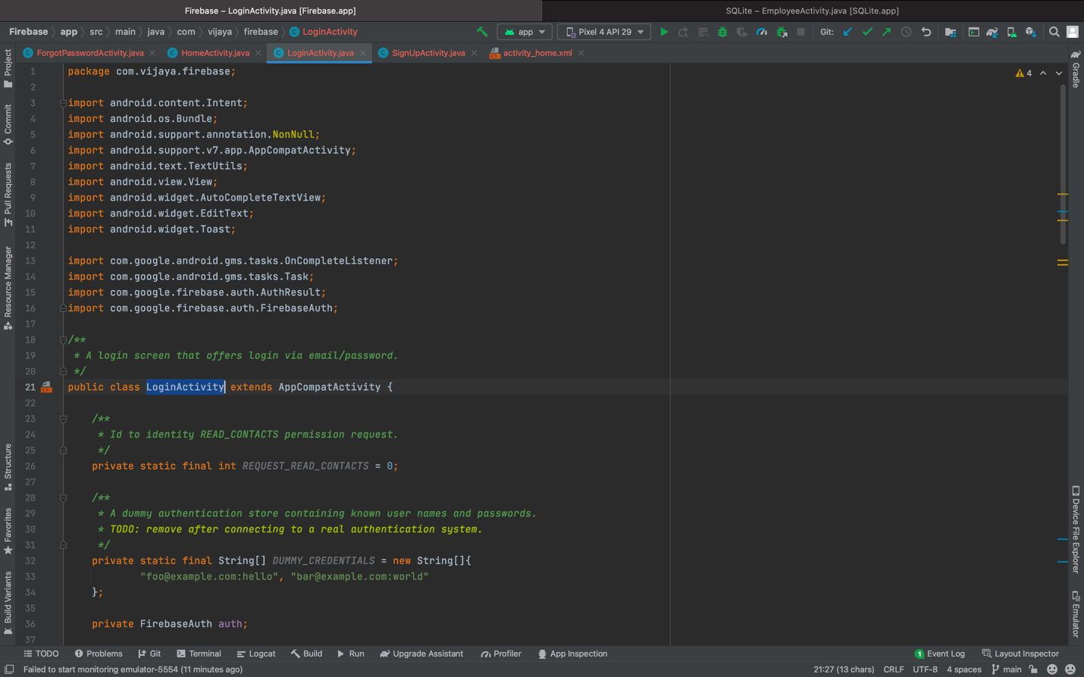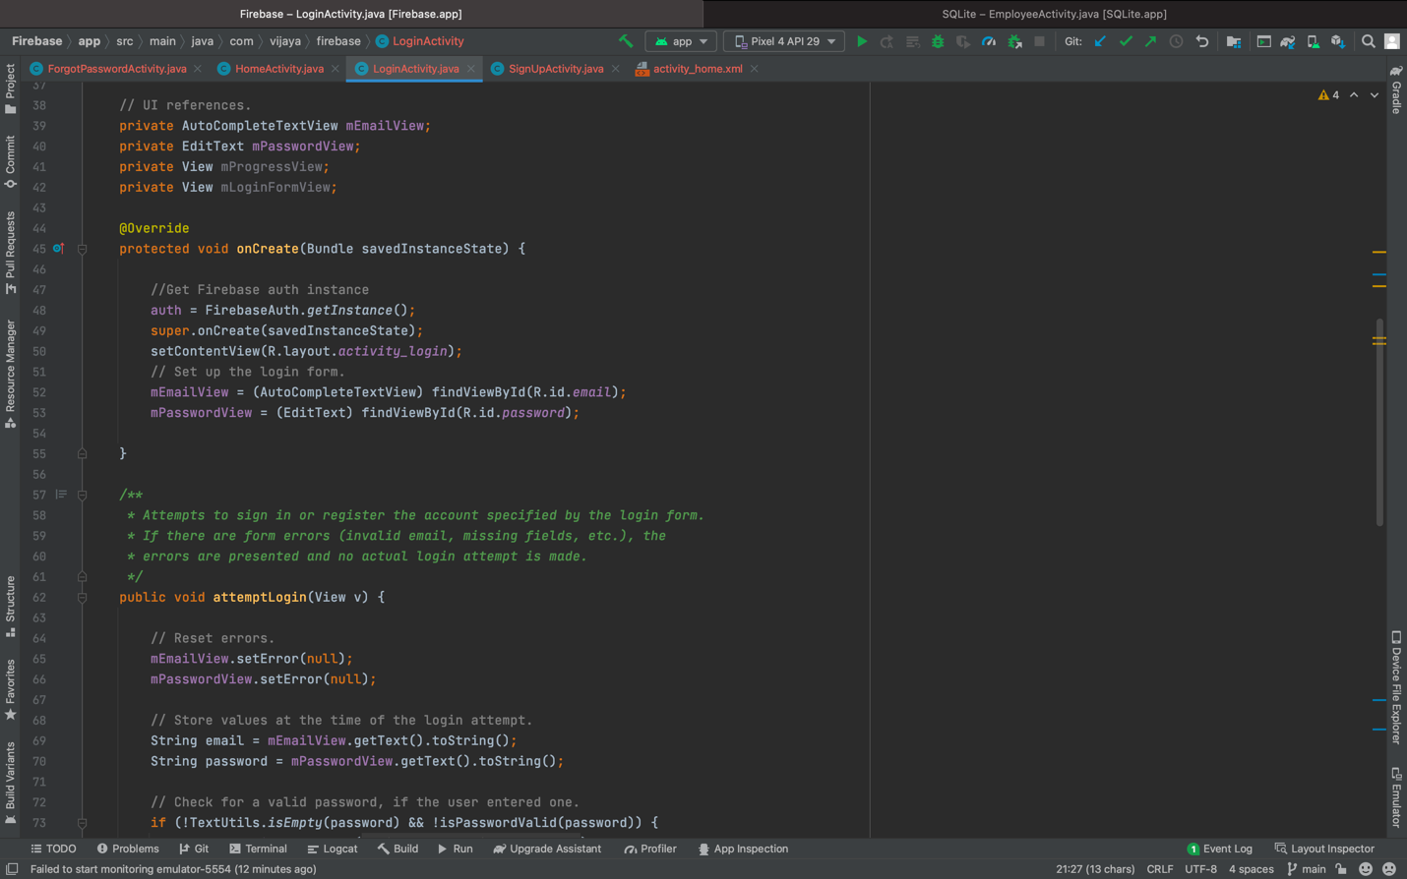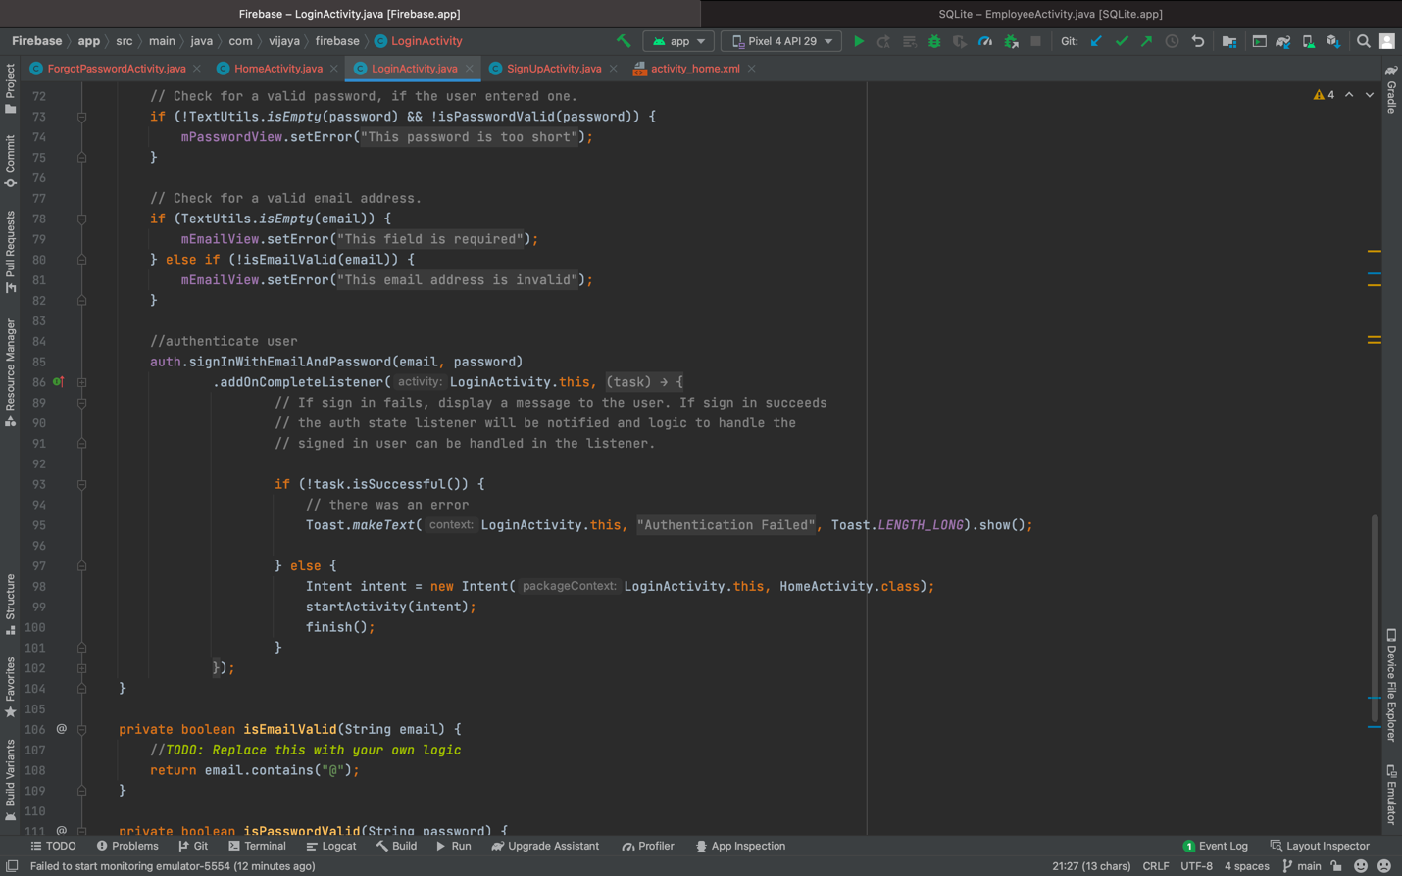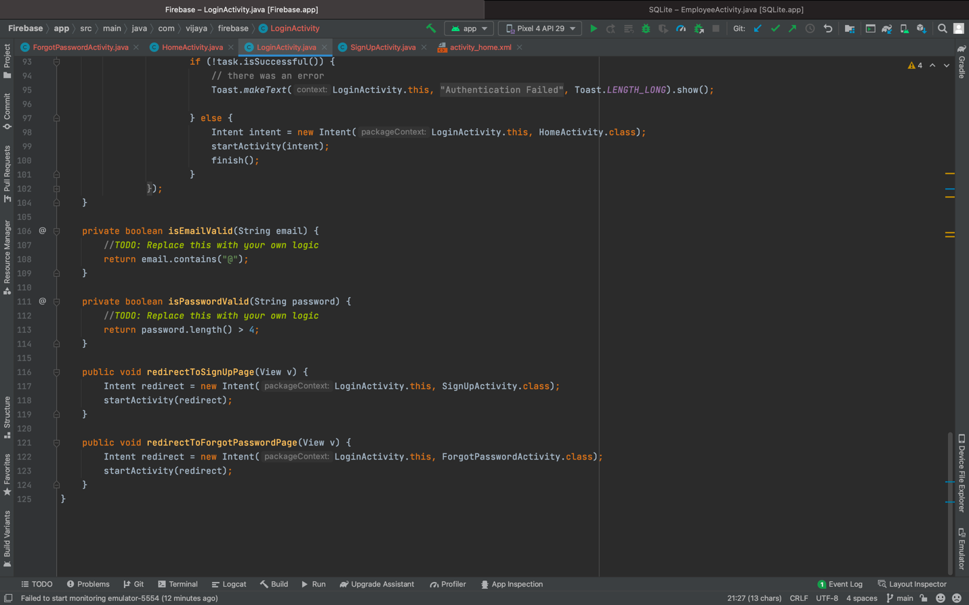

**SignUpActivity:**

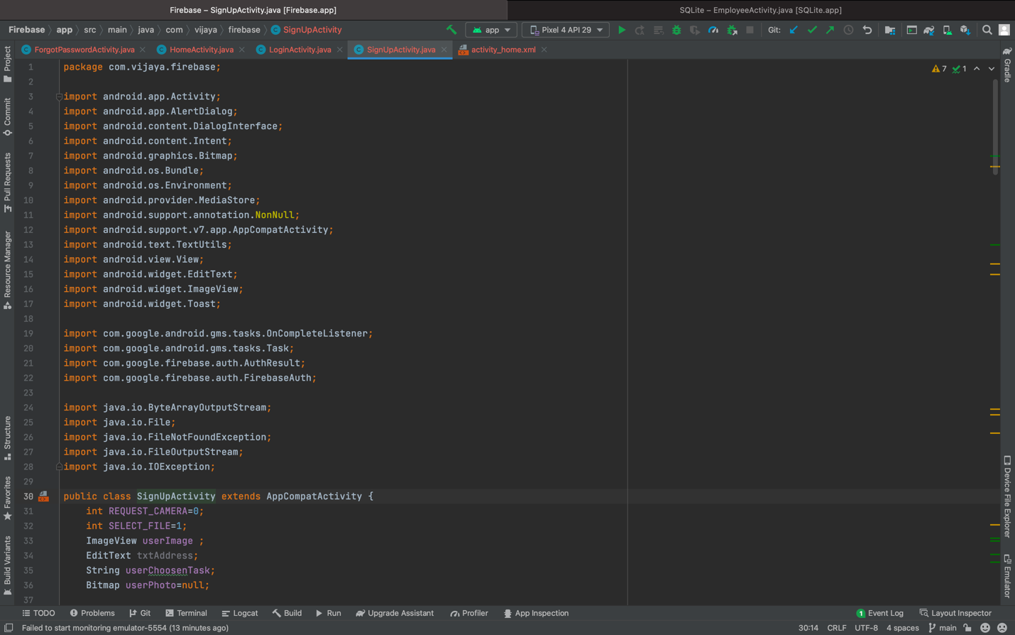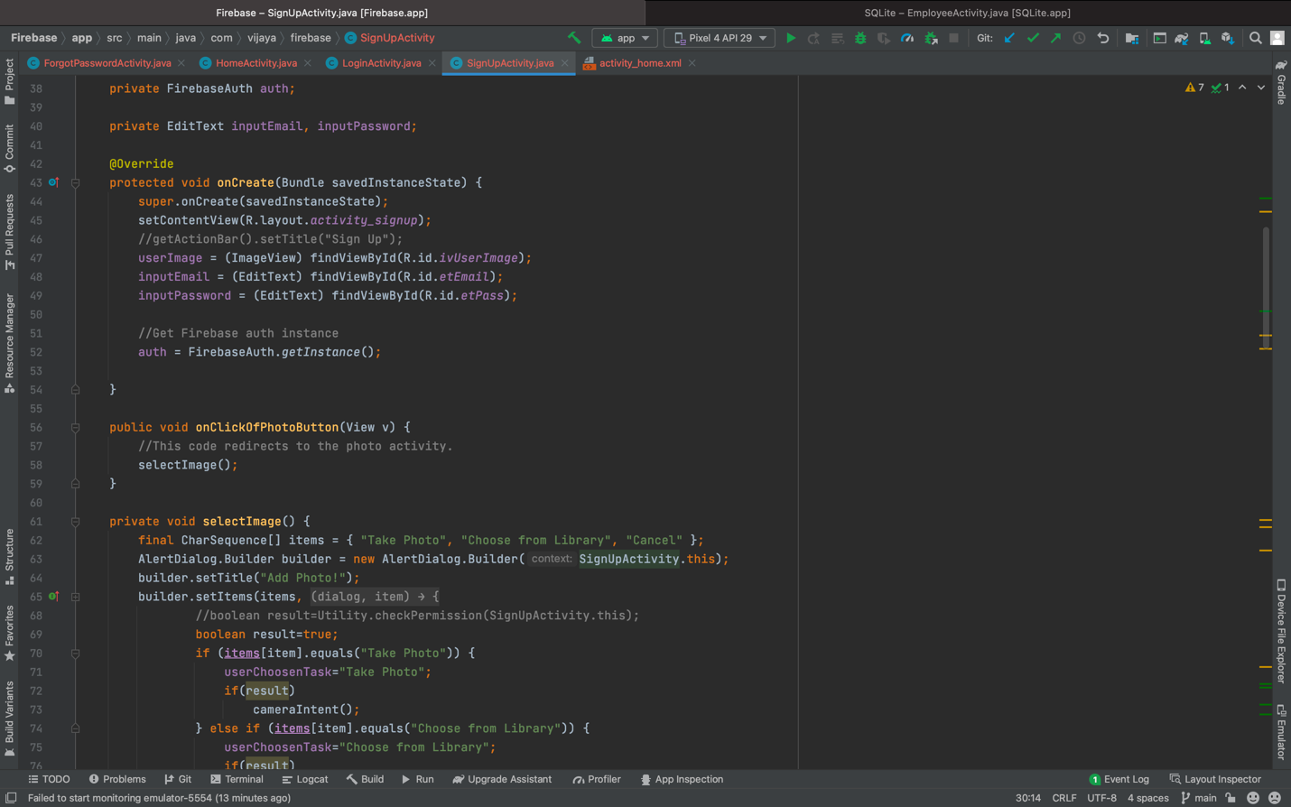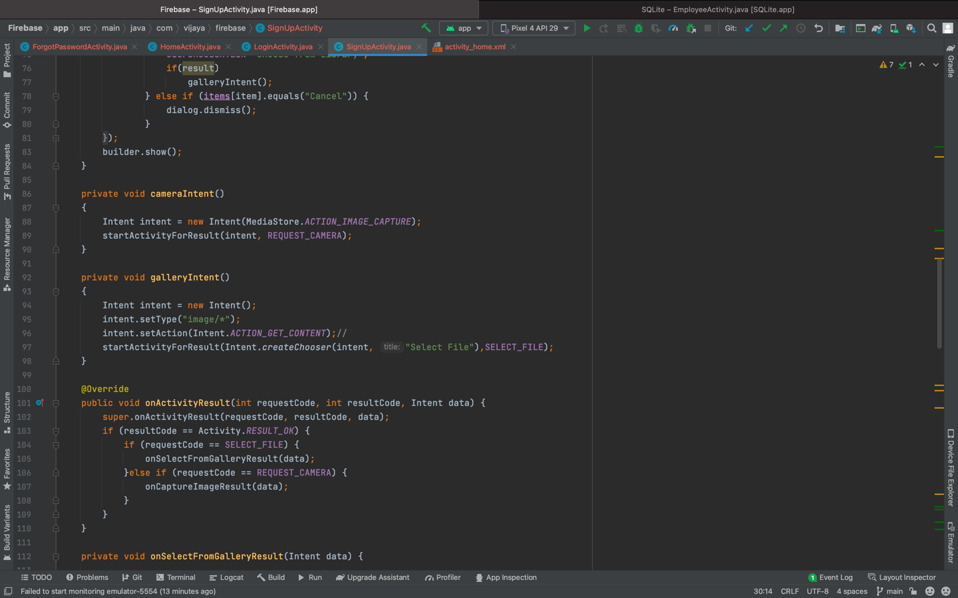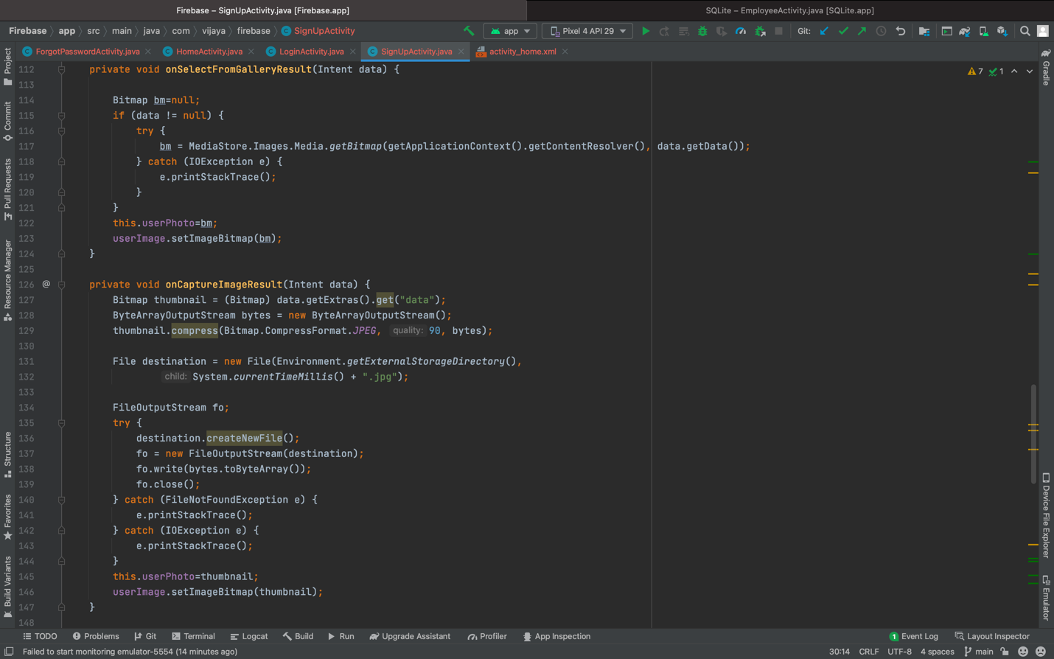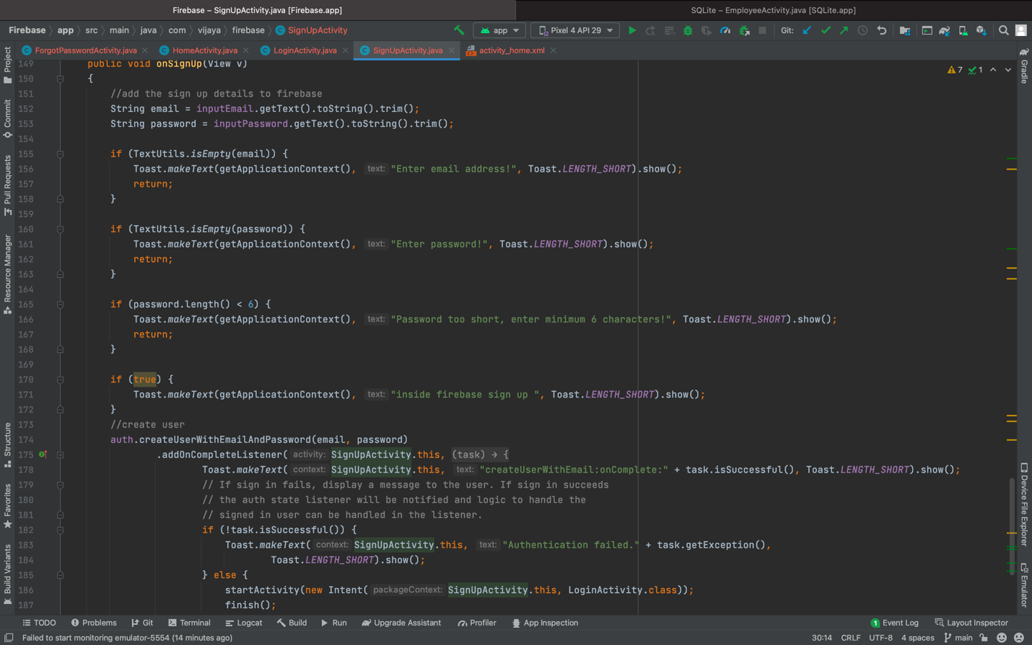

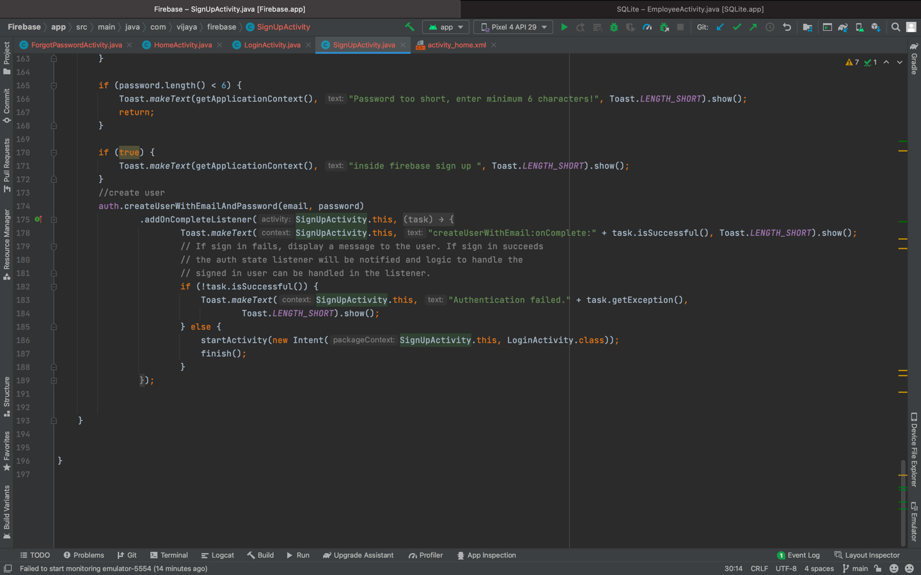

**Layout:**

**Activity_home:**

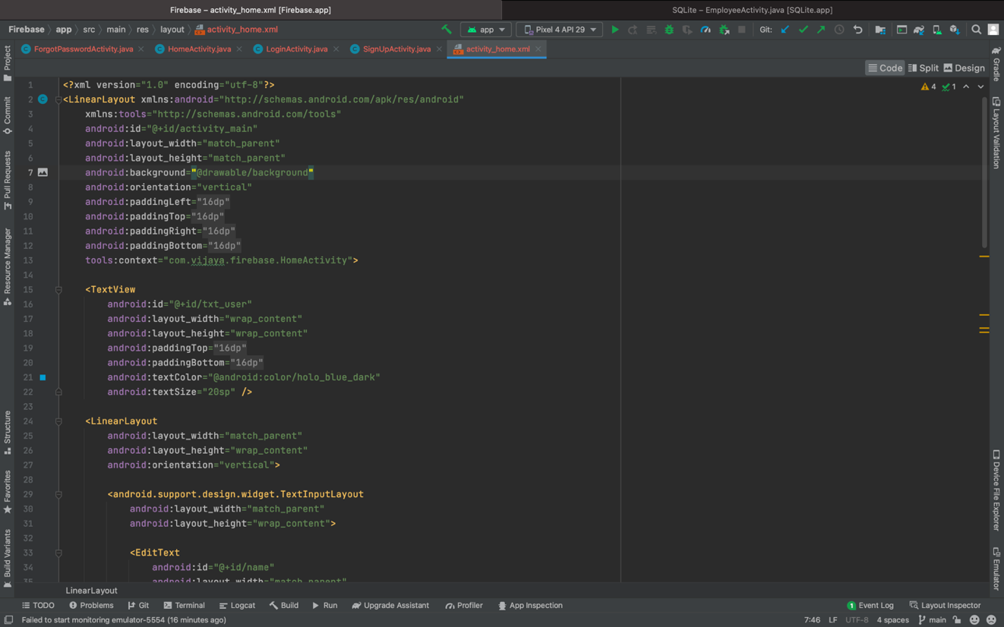

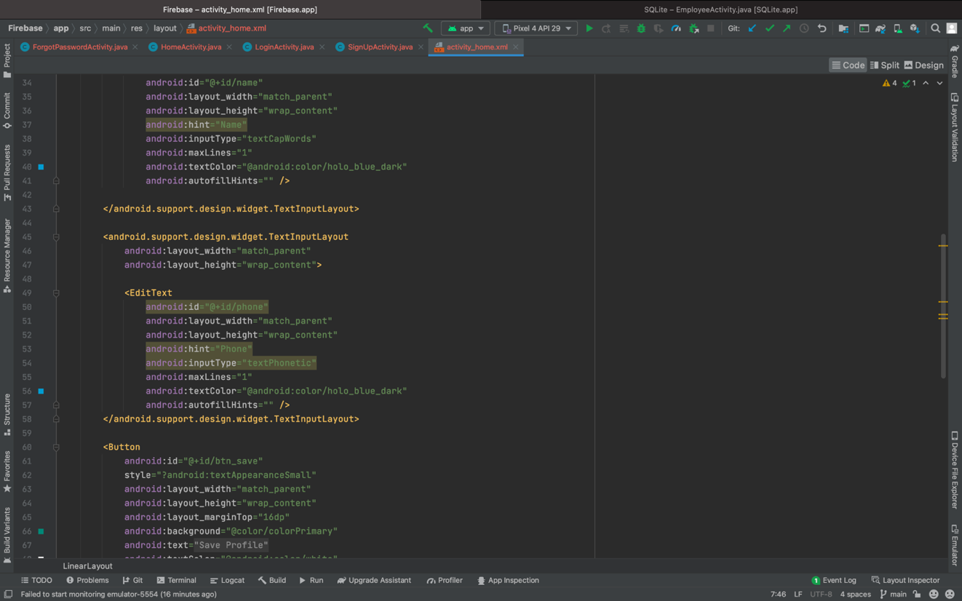

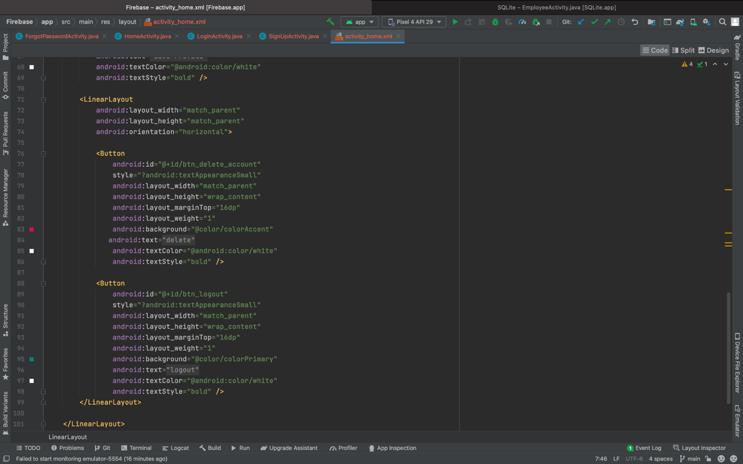

**OUTPUT:**

